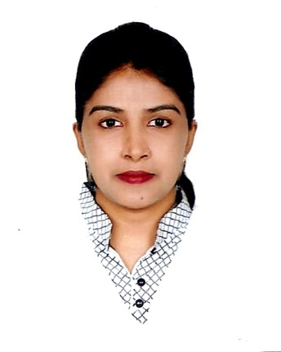**CURRICULUM VITAE**

**OF**

**MASST. RUBI AKTER**

**Mailing Address:**

House-26, Road-22, Sector-14, Uttara, Dhaka-1230.

Cell Phone: +880177274019, 01632183035.

**CARRERE OBJECTIVE:**

I am to build up my career in private sector through a comparative and creative environment. I am highly ambitious to do something different and new which will be helpful for my career as well as my country, nation and society.

**EXPERIENCE:**

* Organization : Ha-meem Group
* Designation : HR Executive & Admin section
* Duration : From 1st December 2013 to 1st July 2017
* Address : Nisat Nagar, Tongi, Gazipur.

**PRESENT POSITION:**

* Organization : Luna Fashion Ltd.
* Designation : HR & Compliance Officer
* Duration : From 13th August 2017, till now
* Address : Joy Bangla road, Khilkur, Joydebpur, Gazipur.

**ACADEMIC QUALIFICATION’S:**

* **L.L.B:**
* Institute : Uttara Law College.
* Result : Pass
* Passing Year : 2014
* **Masters of Arts (M.A):**
* Institution : Govt. BM College, Barisal
* Result : 2nd Class
* Passing Year : 2009
* Subject : History
* University : National University
* **Bachelor of Arts (Honors):**
* Institution : Govt. BM College, Barisal
* Result : 2nd Class
* Passing Year : 2008
* Subject : History
* University : National University
* **Higher Secondary School Certificate (H.S.C):**
* Institution : Betagi Degree College, Borguna.
* Board : Barisal
* Group : Humanities
* Passing Year : 2003
* Result : GPA-2.10
* **Secondary School Certificate (S.S.C):**
* Institution : Halta Dawatala Somobary Maddhomic School.
* Board : Jessore
* Group : Humanities
* Passing Year : 2000
* Result : 2nd Division

**PERSONAL INFORMATION:**

Nick Name : Masst. Rubi Akter

Father’s Name : Md. A. Mannan Faragi

Mother’s Name : Shera Begum

Date of Birth : 21/02/1985

Nationality : Bangladeshi (By Birth)

Religion : Islam

Marital Status : Married

Sex : Female

Blood Group : B+

Height : 4’9”

Weight : 48 Kg

NID No : 0414711531336

**LANGUAGE PROFANELY:**

* Bangla & English reading, writing & speaking.

**COMPUTER LITERACY:**

* I have to know about Computer Application with MS Office, Excel, Power Point.
* Networking & Internet Brewing.

**PERMANENT ADDRESS:**

* Village : South Volanathpur.
* Post Office : Betagi
* Police Station : Betagi
* District : Borguna

**REFERENCE:**

1.**ENG. A.Z.M MAINUL ISLAM** 2. **T.M SHAHEEN**

Dhaka Electric Supply Company Ltd. G.M.S Composite Knting IND Ltd.

(DESCO) House No-110, Road- 06, Mohakhali,

Contract Number: +8801755637596 D.O.H.S, Dhaka.

Mobile: +8801827956181

**DECLARATION:**

I do hereby declare that the above information is true and correct to the best of my knowledge.



Signature

Date: 21/11/2017